MILESTONE 8:Performance Testing
Amount of Data Loaded

"Amount of Data Loaded" refers to the quantity or volume of data that has been imported, retrieved, or loaded into a system, software application, database, or any other data storage or processing environment. It's a measure of how much data has been successfully processed and made available for analysis, manipulation, or use within the system.
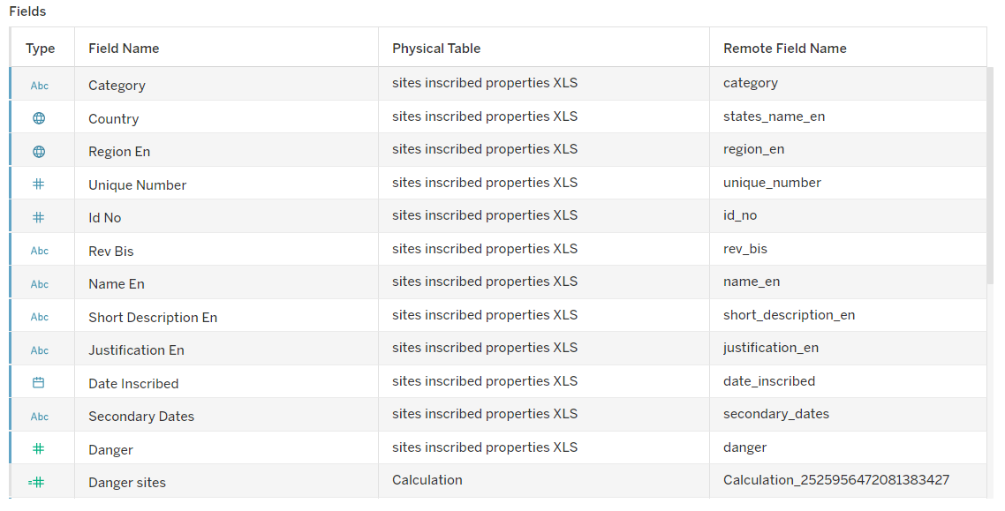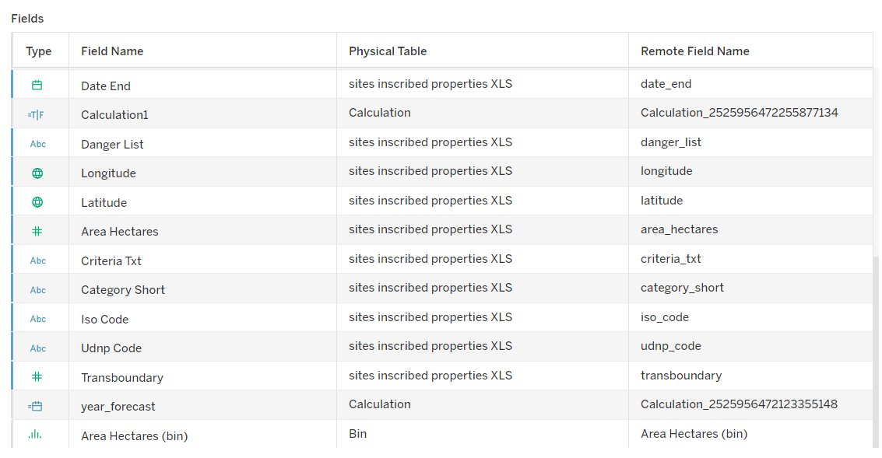

MILESTONE 9:Amount of Data Loaded
"Amount of Data Loaded" refers to the quantity or volume of data that has been imported, retrieved, or loaded into a system, software application, database, or any other data storage or processing environment. It's a measure of how much data has been successfully processed and made available for analysis, manipulation, or use within the system.

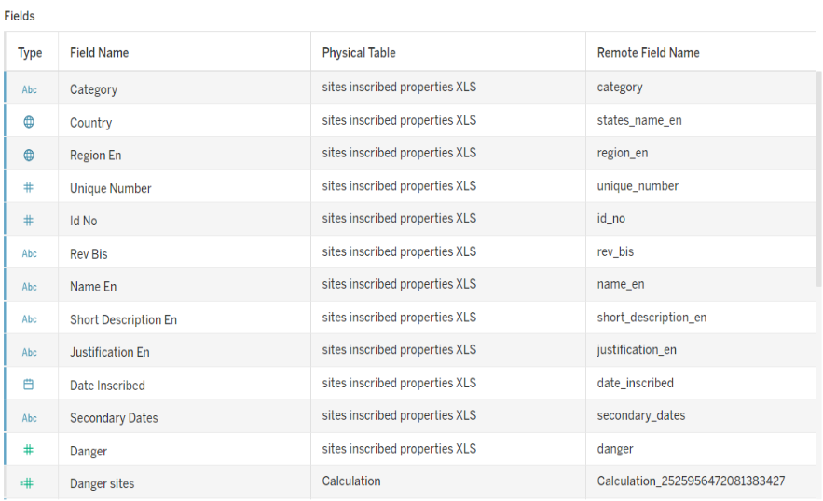

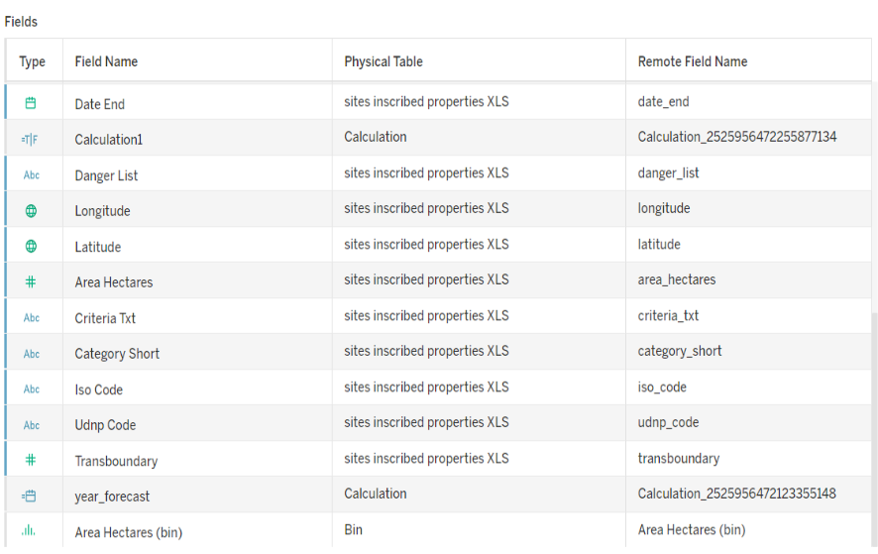

Utilization of Data Filters
"Utilization of Filters" refers to the application or use of filters within a system,software application, or data processing pipeline to selectively extract, manipulate, oranalyze data based on specified criteria or conditions

Activity 2.1: Selected “Latin America” as a filter.
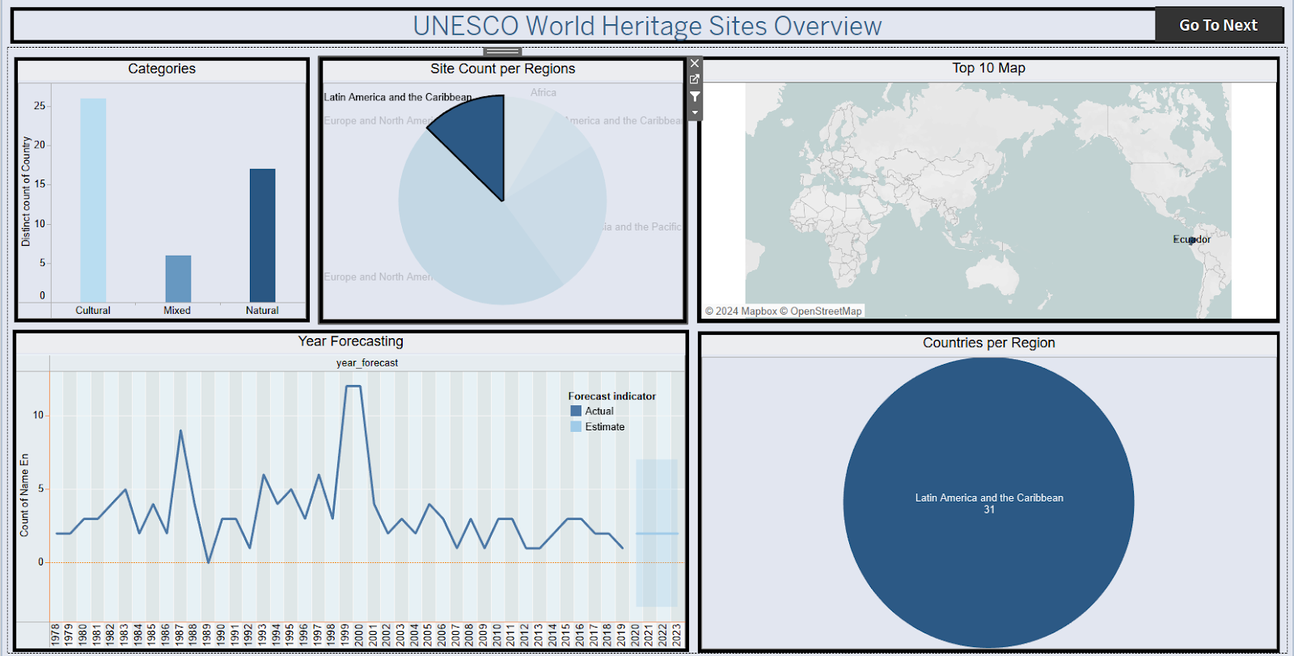

Activity 2.2: Selected “Europe and North America” as a Filter
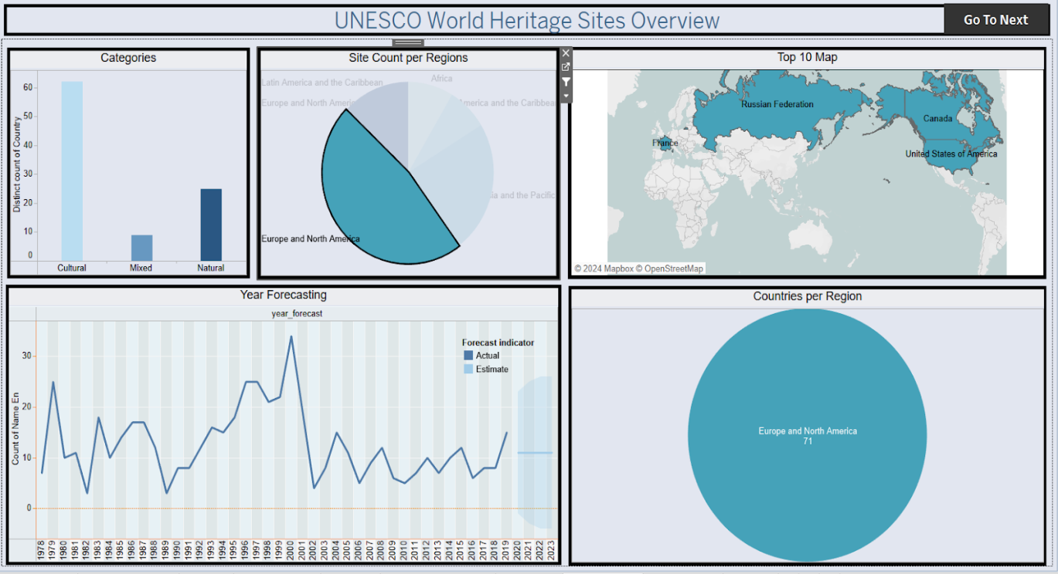
No of Visualizations/ Graphs
- Top 10 regions by area
- Countries per Regions
- Sites Count per Region
- Analysis of Danger sites and Areas
- Heritage ended Regions
- Year Forecasting
- Categories by site count
- Top 10 danger sites

